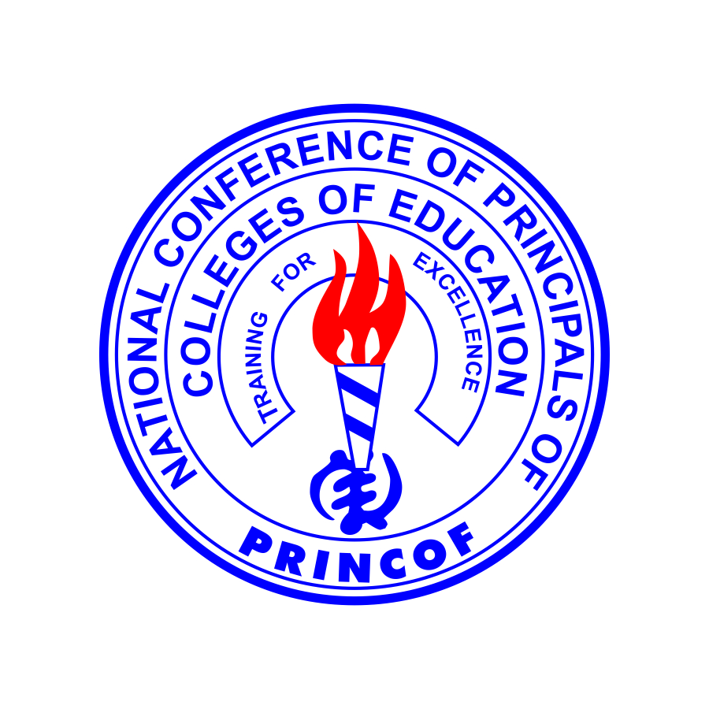
COLLEGES OF EDUCATION- GHANA
ADMISSION TO THE FORTY-SIX (46) PUBLIC COLLEGES OF EDUCATION 2019/2020 ACADEMIC YEAR
Applications are invited from suitably qualified candidates for admission to the NEW FOUR YEAR BACHELOR OF EDUCATION (B.Ed)DEGREE PROGRAMME in the Forty-Six (46) Public Colleges of Education in Ghana for the 2019/2020 academic year.
Admission Requirements:
- WASSCE /SSSCE Qualification Applicants
The general requirement for admission to the Bachelor of Education (B.Ed) Programme is as follows:

- WASSCE Holders: CREDIT (A1-C6) in Six (6) subjects comprising Three(3) Core subjects, including English Language and Core Mathematics, and Three (3) Elective subjects relevant to the course of study.

- SSSCE Holders: CREDIT (A-D) in Six (6) subjects comprising Three (3) Core subjects, including English Language and Core Mathematics, and Three(3) Elective subjects relevant to the course of study

- Holders of TVET Qualifications: CREDIT in Three Core Subjects including English and Mathematics and PASSES in Three Elective Subjects relevant to the course of study.

- Candidates awaiting the MAY/JUNE, 2019 WASSCE and NABPTEX RESULTS can also apply.

The specific requirements for admission to the various COURSE OPTIONS on offer within the BACHELOR OF EDUCATION PROGRAMME are as detailed below:

TABLE I: Entry Requirements for the Various Course Options within the BACHELOR OF EDUCATION programme.
Programme Options | WASSCE Applicants | SSCE Applicants
B.Ed. GENERAL(With Specializations in Primary and Junior High School). | Credit (A1-C6)in Three (3) CORE subjects, including English Language and Mathematics, and Three (3) Elective subjects relevant to the course of choice | Credit (A-D) in Three (3) CORE subjects including English Language and Mathematics, and Three (3) Elective subjects relevant to the course of choice
B.Ed. SCIENCE & MATHEMATICS | Credit (A1-C6) in Three (3)CORE subjects including English Language and Mathematics and Three (3) Elective Subjects relevant to the course of choice. | Credit(A-D) in (3) CORE subjects including English Language and Mathematics and Three (3) Elective Subjects relevant to the course of choice.
B.Ed. EARLY CHILDHOOD EDUCATION | Credit(A1-C6) in Three (3)CORE subjects including English Language and Mathematics and Three (3) Elective Subjects relaxant to the course of choice. | Credit (A-D) in Three (3)CORE subjects including English Language and Mathematics and Three (3) Elective Subjects relevant to the course of choice.
B.Ed. FRENCH | Credit(A1-C6) in Three (3)CORE subjects including English Language and Mathematics and Three (3) Elective subjects including FRENCH. | Credit (A-D) in Three (3) CORE subjects including English Language and Mathematics and Three(3) Elective subjects including FRENCH.
B.Ed. TECHNICAL/VOCATIONAL  (APPLICANTS WITH TVET QUALIFICATIONS) | CREDIT in Three (3)CORE subjects including English Language and Mathematics and PASSES inThree (3) Elective subjects relevant to the Technical/ Vocational Course.
B.Ed TECHNICAL/VOCATIONAL  ( APPLICANTS WITH WASSCE/SSSCE QUALIFICATIONS) | CREDIT in Three Core subjects, including English and Mathematics and Three elective subjects relevant to the Technical/ Vocational Course. | CREDIT ( A-D) in Three Core Subjects including English Language and Mathematics and Three Elective Subjects relevant to the Technical/ Vocational Course..

TABLE II: Entry requirements for Special Needs Applicants
SPECIAL NEEDS APPLICANTS:  VISUALLY IMPAIRED  Study facilities are available at:  N.J. Ahmadiyya, College of Education, WA  Wesley College of Education, KUMASI and  Presbyterian College of Education, AKROPONG | Credit(A1-C6) in Two (2) CORE subjects including English Language and Social Studies and Three (3) relevant elective subjects. | Credit (A-D) in Two (2) CORE subjects including English Language and Social Studies and Three (3) relevant elective subjects.
SPECIALNEEDS APPLICANTS:  HEARING IMPAIRED  Study facilities are available at Presbyterian College of Education, AKROPONG. | Credit (A1-C6) in Three (3)CORE subjects including English Language and Mathematics and Three (3) relevant Elective subjects. | Credit (A-D) in Three (3)CORE subjects including English Language and Mathematics and Three(3) relevant Elective subjects.

- Online Application Procedure:
Applicants will first make a payment of One Hundred and Seventy Ghana Cedis (GHC 170.00) into the Colleges of Education- Ghana Account at any branch of the following bank nationwide:

- Consolidated Bank Ghana Limited.
ii) Additionally, payment can also be made through mobile money wallet: Tigo Cash, Vodafone cash, Airtel Money, and MTN Mobile Money by dialling short code *924*8# from all networks.
- Upon payment, applicants will be given the following information:
- A Personal Identification Number (PIN).
- An Admission Application Serial Number.
- The Admission Website Address- admission.coeportal.edu.gh

- With this PIN, applicants will then visit the Colleges of Education admission website: admission.coeportal.edu.gh and follow specific guidelines to fill the online application form.
- Applicants should select three Colleges of their choice for their Program and an accompanying Ghanaian Language.
NOTES
- Applicants are advised to read and to ensure they fully understand all related instructions before completing the application form.

- Applicants are to note that application forms not properly completed will not be processed.
- After completing the online application form, an applicant will need to print a copy which should be sent with one passport photograph and a copy/copies of their results slips (where available) by EMS priority envelope obtainable from Ghana Post nationwide and addressed to: The Principal of the COLLEGE chosen.

- Applicants will be notified of the receipt of their applications by SMS (text message) and should therefore provide correct and reliable cellphone numbers when completing the form online.

- Applicants will also receive admission offer notifications by SMS and those who do not receive such notifications may understand it to mean that their applications were not successful.

- Applicants are to note that the Colleges will cross-check their results from the West African Examinations Council as part of the admission process. Applicants found to have submitted fake or falsified documents in support of their applications will be made to face the legal consequences of their actions.

NB: Applicants should note that the College selected determines the University to which the College is affiliated.

UNIVERSITY OF GHANA (UG) | UNIVERSITY FOR DEVELOPMENT STUDIES (UDS)
Accra College of Education Peki College of Education Mount Mary College of Education, Somanya  Enchi College of Education E.P College of Education, Amedzofe  Gbewaa College of Education, Pusiga | Tumu College of Education McCoy College of Education,Nadowli  Dambai College of Education  Gambaga College of Education  St. Vincent College of Education, Yendi Al-Faruq College of Education, Wenchi
UNIVERSITY OF CAPE COAST (UCC)  Foso College of Education  St.Francis College of Education, Hohoe  OLA College of Education, Cape Coast  Kibi College of Education  Holy Child College of Education, Takoradi  St. Teresa’s College of Education, Hohoe  Jasikan College of Education  Berekum College of Education  St. Monica’s College of Edcation, Mampong-Ash.  Atebubu College of Education  Offinso College of Education  S.D.A College of Education, Agona-Ash.  Abetifi College of Education  St. Ambrose College of Education, Dormaa-Akwamu | UNIVERSITY OF EDUCATION WINNEBA (UEW) St. Louis College of Education, Kumasi Presby Women’s College of Education, Aburi. S.D.A. College of Education, Koforidua Agogo Presby College of Education  Methodist College of Education, Oda Bia-Lamplighter College of Education  Presby College of Education, Akropong-Akwapim  Komenda College of Education  TECHNICAL AND VOCATIONAL EDUCATION AND TRAINING (TVET) Mampong Tech. College of Education  Ada College of Education  Akatsi College of Education  Bagabaga College of Education, Tamale N.J. Ahamadiyya College of Education, Wa  St. John Bosco’s College of Education, Navorong Wiawso College of Education
KWAME NKRUMAH UNIVERSITY OF
SCIENCE AND TECHNOLOGY (KNUST)
Akrokerri College of Education
Wesley College of Education, Kumasi
St. Joseph’s College of Education, Bechem
Tamale College of Education
E.P College of Education, Bimbilla

APPLICATION PERIOD:
Admissions will open on Monday, 25th March 2019 and close on Wednesday, 31st July 2019.

Executive Secretary
PRINCOF Secretariat
Accra.

